Role of feeding rate in energy consumption and mechanical properties for different types of feed pellet
Dabbour, M., Bahnasawy, A., Ali, S and Z. El- Haddad
Agric. Eng. Dept., Faculty of Agric., Benha Univ., Egypt.
E-mail: adel.bahnasawy@fagr.bu.edu.eg
ABSTRACT
The experiments of this study were carried out to optimize some pelletization parameters and their effects on the quality of feed processing. The pelletizer was evaluated under different parameters including feeding rate and feed pellets. Pelletization process was evaluated by studying the specific energy consumption and quality of feed pellets at different operation conditions. The pelletization energy consumption ranged from 179.14- 204.60 kJ/kg for rabbits, 163.60- 184.87 kJ/kg for poultry and 41.06- 59.67 kJ/kg for large animal feed pellets. The compression and shear forces of pellets ranged from 277.16- 309.11 and 30.12- 38.02 N, respectively for rabbits feed pellet, 99.22- 106.08 and 25.60- 29.60 N, respectively for poultry feed pellets and 135.63- 242.08 and 59.92- 104.66 N, respectively for large animals feed pellets.
Keywords: pelletization, energy consumption, compression force, shear force, feed pellet.
INTRODUCTION
The predominant process of pressing agglomeration is pelleting. The process of pressing agglomeration is high energy- consuming. The main source of the energy consumption is a pelletizer. Energy consumption of pelleting depends on the kinds of feed mixtures, physical properties of components, technical and technological process parameters and method of realization. Efficiency and energy consumption of the installation depends also on the hole diameters in the die (Opielak, 1997and Romański, 1999). The technology of poultry feed processing involves a wide range of thermal treatments including extrusion, expansion, conditioning and pelleting. Although pelleting represents the greatest energy expenditure in the feed manufacturing process, when the cost-benefit is considered, pelleting is cost effective and the most widely used thermal processing method. The main aim of pelleting is to agglomerate smaller feed particles by the use of mechanical pressure, moisture and heat (Peisker, 2006).
Feed costs account for 60-65% of total broiler production costs. Pellet production costs are largely determined by the price of raw materials and the energy consumption of the process, in which approximately 60% of energy is used for pelleting (Cutlip et al., 2008). The pelleting mixed feeds for pig's average demand for electrical energy consumption is 46.6 kWh/t, and for thermal energy in the form of steam 29.8 kWh/t (Beumer, 1980). Feed mixture pelleting is connected with considerable energy expenditures, usually varying from several to about 70 kWh/t (Skoch et al., 1981; Wood, 1987; Briggs et al., 1999 and Laskowski and Skonecki, 1999).
In general, the specific energy required for pelleting (i.e., energy consumed by the pellet mill motor) may range from 4 to 40 kWh/t (Israelsen et al., 1981; Stevens, 1987 and Tabil et al., 1997). In addition, steam conditioning/preheating the feed may require considerable energy. For example, Skoch et al. (1981) estimated that steam conditioning to increase the temperature from 27 to 80 ^{ο}C consumed about 26 kWh/t. Steam add in its pelleting operations improves pellet durability. Added steam provides heat and moisture and it also helps to reduce energy consumption during pelleting. Tabil et al. (1996) related the specific energy consumed by the pellet-mill motor to the alfalfa pellet durability. Their study showed that increasing specific energy input from 26.5 to 33.0 kWh/t increased the pellet durability from 25 to 80%.
Kulig and Laskowski (2005) studied the increase in fat concentration in feed material from 2 to 5.5% reduces energy consumption during pelleting by 30%, on average. Kulig and Laskowski (2009) presented the results of a study investigating the effect of the soybean oil content (0 to 6%) of broiler premium grower diets on energy consumption during the pelleting process. The study was performed on a test stand equipped with a microprocessor- supported system for measuring steam, heat and electric energy consumption. It was found that the mean values of unit thermal energy consumption ranged from 135.41 to 161.23 kJ∙kg⁻¹. Mean unit pressing energy expenditure values were determined in the range from 88.11 to 129.44 kJ∙kg⁻¹. Kulig and Laskowski (2008) presented the results of a study investigating the effect of particle size of ground barley and lupine (in the range of 0.25 to 2.5 mm) on energy consumption during the pelleting process. The study was performed on a test stand equipped with a microprocessor-supported system for measuring steam, heat and electric energy consumption. It was found that the mean values of unit thermal energy consumption ranged from 97.21 to 130.33 kJ.kg⁻¹ for lupine and from 111.35 to 145.49 kJ.kg⁻¹ for barley. Mean unit pressing energy expenditure values were determined in the range from 77.71 to 98.65 kJ.kg⁻¹ for lupine and from 97.54 to 125.11 kJ.kg⁻¹ for barley.
The main aim of this study is to investigate the effect of pelletization parameters on the energy consumption and quality of feed pellets.
MATERIALS AND METHODS
1. Materials:
1.1. Raw materials used in feed manufacturing:
The feed ingredients of these recipes are shown in table 1.

Table 1 Feed ingredients of three feed pellets.
Ingredients | Large animal feed | Rabbit feed | poultry feed
Yellow corn (9% protein), % | 40 | 13 | 70
Soybean meal (44% protein), % | 10 | 24 | 10
Hay (15% protein), % | - | 21 | -
Wheat bran (11% protein), % | 40 | 19 | 10
Barley (10% protein), % | - | 23 | -
Cotton seed meal (41% protein), % | 10 | - | -
Feed additives, % | - | - | 10

1.2. Pelletizer used for conducting pelletization experiment:
A locally made pelletizer that driven by 75 hp motor was used. The power is transmitted by a set of V- belt and pulleys (7 belts). The pelletizer consists of feeding hopper, feeder (a screw conveyor driven by 1.5 hp motor), distributer, pelletizing chamber (Die made in Germany, with dimension of 45 cm outer diameter and 35 cm inside diameter with a thickness of 5 cm and hole diameter of 0.3 and 1.2 cm), a set of hardened shell with indentations on the surface rollers with a diameter of 15 cm and finally a set of knives to cut off the pellets to the proper lengths. The specifications of the pelletizer are listed in table 2 and shown in fig. 1.
Table 2 The pelletizer specifications.
Items | Values
Source of power | AC Motor (75 hp)
Outer die diameter, cm | 45
Inside die diameter, cm | 35
Die thickness, cm | 5
Effective width, cm | 10.2
Total width, cm | 14.2
hole diameter, cm | 1.2, 0.3
Diameter of roller, cm | 15
Length of roller, cm | 10
Rotational speed of motor, rpm | 980
Diameter of motor pulley, cm | 17
Diameter of pelletizer pulley, cm | 68
Die speed, rpm | 245
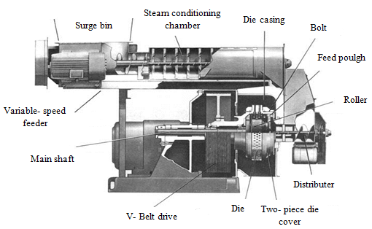
Fig. 1 Schematic diagram of the pelletizer.
1.3. Measuring devices:
The power requirement (kW) was determined by recording the voltage and current strength by using the clamp meter (made in China, Model DT266, measuring range 200/1000A and 750/1000V with an accuracy of ± 0.01) to measure the line current strength (I) and the potential difference value (V). Digital balance (made in China, model YH-T7E, measuring range of 0- 300 kg ± 0.05 kg) was used during the experiment execution. A digital tachometer (made in Japan, model 461895, measuring range of photo 5 to 99999 rpm and contact 0.05 to 19999 rpm ± 0.05 %) (contact/photo) was used to measure the rotational shaft speeds of the feeder. Digital force gauge was used to measure compression and shear force of the feed pellets (made in Japan, model FGC-20, FGN-20, measuring range of ±20 kg_{f}, ±200 N, ±50 lb_{f} with an accuracy of ± 0.2% of maximum load + 1/2 digit at 23^{ο}C).
2. Methods:
The pelletizer was evaluated at different feeding rates and types of feeds as follows:-
- Four feeding rates of 1.80, 2.00, 2.50 and 3.50 Mg/h for large animal feed pellets.
- Four feeding rates of 0.60, 0.70, 0.80 and 0.90 Mg/h for poultry feed pellets.
- Four feeding rates of 0.40, 0.50, 0.60 and 0.70 Mg/h for rabbits feed pellets
2.1. The specific energy consumption:
Electrical power consumption was estimated from the measured electric current and voltage values and estimated according to Kurt (l979) as follows from equation:
$Ep=\frac{\sqrt{3}*I*V*η*cosφ}{1000}$ (1)
Where Ep is the electrical power, kW, I the electric current, Amperes, η the mechanical efficiency assumed to be 0.95 (Metwally, 2010), V the electrical voltage, V and cos φ the power factors being equal to (0.84).

The specific energy consumption (kJ/kg) was calculated by using the following equation:
$The specific energy consumption=\frac{Total energy consumption}{Productivity}$ (2)
RESULTS AND DISCUSSIONS
1. Pelletizer evaluation:
1.1. Specific energy consumption:
Table 3 and figs (1, 2 and 3) show the effect of feeding rate of the pelletizer on the specific energy consumption in manufacturing feed pellets. It could be seen that the specific energy consumption decreased with increasing the feeding rate, where, it decreased from 204.60 to 178.14 kJ/kg when the feeding rate increased from 0.40 to 0.70 Mg/h for the rabbits feed pellets, with a reduction percentage of 12.93% .

Table 3 Effect of feeding rate of the pelletizer on the specific energy consumption of the feed pellets.
Types of feed | Feeding rate, Mg/h | Specific energy consumption, kJ/kg
Rabbits feed pellets | 0.40 | 204.60
 | 0.50 | 193.17
 | 0.60 | 186.52
 | 0.70 | 179.14
Poultry feed pellets | 0.60 | 184.87
 | 0.70 | 176.13
 | 0.80 | 170.42
 | 0.90 | 163.60
Large animal feed pellets | 1.80 | 59.67
 | 2.00 | 52.73
 | 2.50 | 48.52
 | 3.50 | 41.06

For poultry feed pellets, it was found that the specific energy consumption decreased with increasing the feeding rate also, where they decreased from 188.87 to 163.60 kJ/kg, when the feeding rate increased from 0.60 to 0.90 Mg/h, with a reduction percentage of 13.38%. For large animal feed pellets the specific energy consumption decreased from 59.67 to 41.06 kJ/kg, when the feeding rate increased from 1.80 to 3.50 Mg/h, with a reduction percentage of 31.19%.
The results indicate that the feed pellets of rabbit consumed the highest values of energy (204.60 kJ/kg) at 0.40 Mg/h feeding rate, which the large animal feed pellets pelletization consumed the lowest of values of the energy at higher feeding rates (1.80 to 3.50 Mg/h), which ranged from 41.06 to 59.67 kJ/kg. This is could attributed to that the rabbit feed pellets take more time in compression due to three reason higher content of fiber, lower bulk density and smaller die diameter.

Regression analysis was carried out to find a relationship between the feeding rate of the pelletizer and specific energy consumption of the feed pellets. The most suitable forms obtained were listed in table 4:

Table 4 Relationship between the feeding rate of the pelletizer on the specific energy consumption of the different feed pellets their constants and coefficient of determinations.
Type of feed | Variables |  | Constants |  | R²
 | Dependent | Independent | A | B
Rabbits feed pellets | SEC | Fr | -83.03 | 236.52 | 0.98
Poultry feed pellets | SEC | Fr | -69.55 | 225.91 | 0.99
Large animal feed pellets | SEC | Fr | -9.81 | 74.54 | 0.91

Where SEC is the specific energy consumption, kJ/kg, Fr the feeding rate, Mg/h, A slope and B intercept.
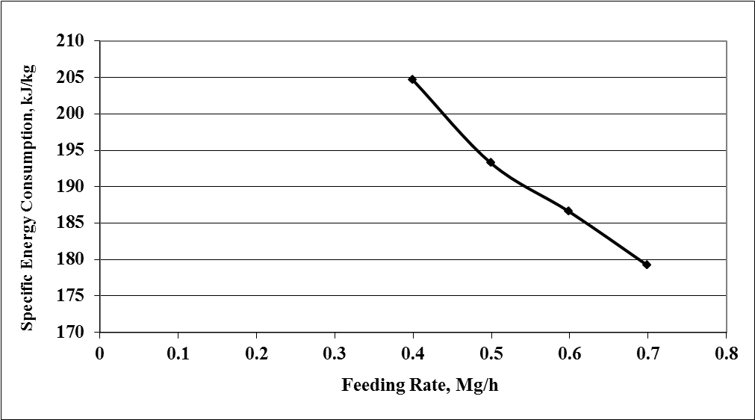
Figure 1 The effect of feeding rate of the pelletizer on the specific energy consumption of the rabbits feed pellets.

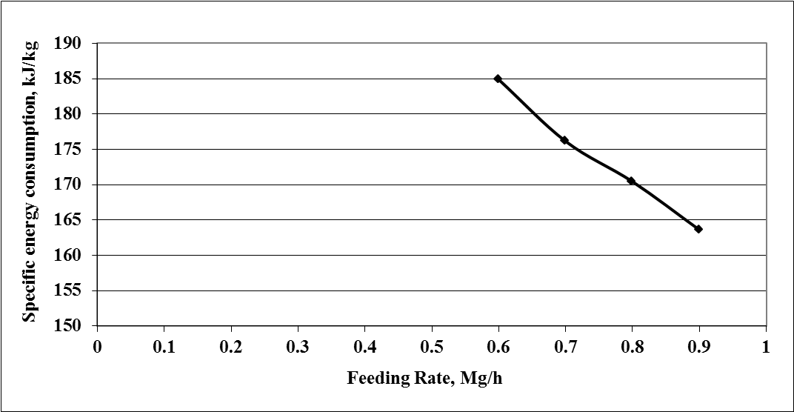
Figure 2 The effect of feeding rate of the pelletizer on the specific energy consumption of the poultry feed pellets.
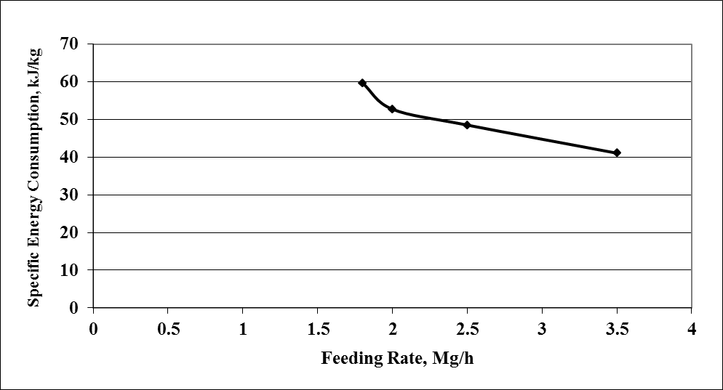
Figure 3 The effect of feeding rate of the pelletizer on the specific energy consumption of large animal feed pellets.
2.1. Mechanical properties of feed pellets:
2.1.1. Compression and shear forces:
Table 5 and figs (4, 5 and 6) show the effect of feeding rate of the pelletizer on the compression and shear force of the feed pellets. It could be seen that the compression and shear force increased with increasing the feeding rate, where they increased from 277.16 to 309.11 and 30.12 to 38.02 N, respectively, when the feeding rate increased from 0.40 to 0.70 Mg/h for the rabbit feed pellets. The increasing percentage was 10.34 and 20.78%, respectively. For poultry feed pellets, it was found out that the compression and shear forces increased with increasing the feeding rate also, where they increased from 99.22 to 106.08 and 25.60 to 29.60 N, respectively, when the feeding rate increased from 0.60 to 0.90 Mg/h. The increasing percentage was 6.47 and 13.51%, respectively. For large animal feed pellets, it was found out that the compression and shear forces increased with increasing the feeding rate also, where they increased from 135.63 to 242.08 and 76.10 to 104.66 N, respectively, when the feeding rate increased from 1.80 to 3.50 Mg/h. The increasing percentage was 43.97 and 27.29%, respectively.

Table 5 Effect of feeding rate of the pelletizer on the compression and shear forces of affected feed pellets.
Types of feed | Feeding rate, Mg/h | Compression force, N | Shear force, N
Rabbits feed pellets | 0.40 | 277.16 | 30.12
 | 0.50 | 294.81 | 34.29
 | 0.60 | 303.05 | 37.13
 | 0.70 | 309.11 | 38.02
Poultry feed pellets | 0.60 | 99.22 | 25.60
 | 0.70 | 101.29 | 27.11
 | 0.80 | 103.15 | 27.60
 | 0.90 | 106.08 | 29.60
Large animal feed pellets | 1.80 | 135.63 | 59.92
 | 2.00 | 171.51 | 76.10
 | 2.50 | 197.03 | 93.81
 | 3.50 | 242.08 | 104.66

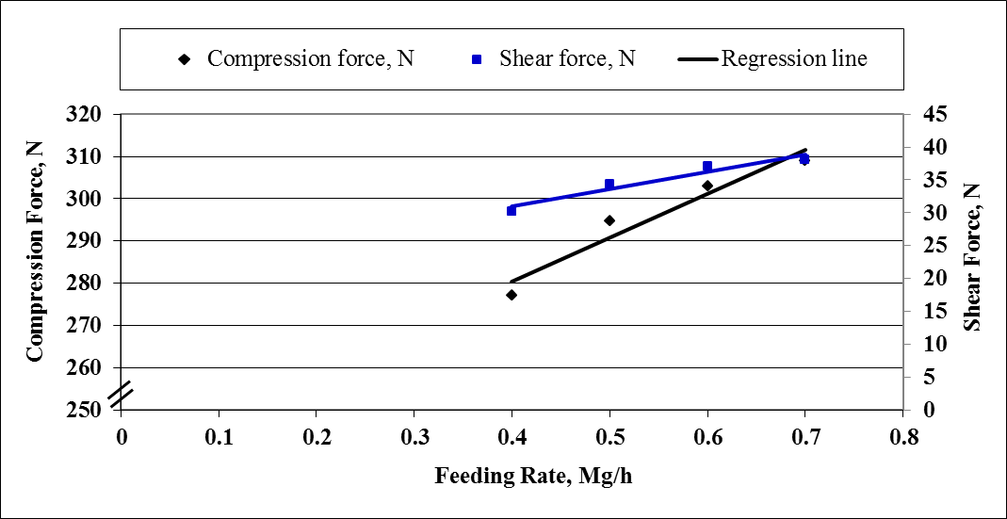
Figure 4 The effect of feeding rate of the pelletizer on the compression and shear forces of the rabbits feed pellets.

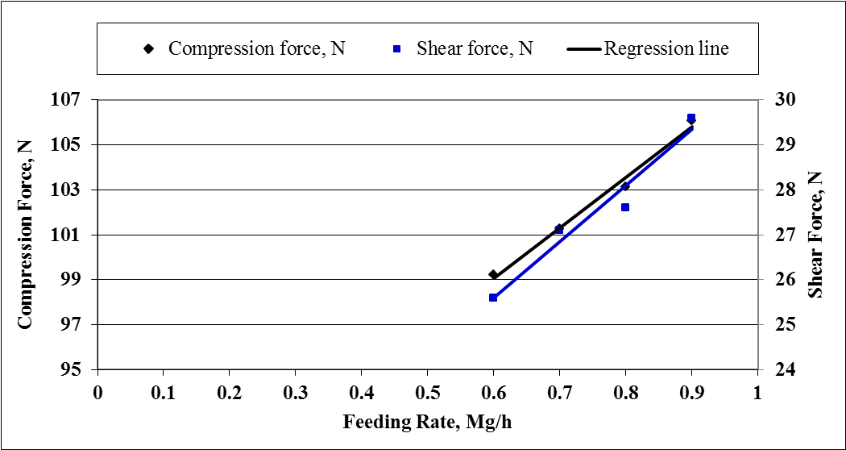

Figure 5 The effect of feeding rate of the pelletizer on the compression and shear forces of the poultry feed pellets.
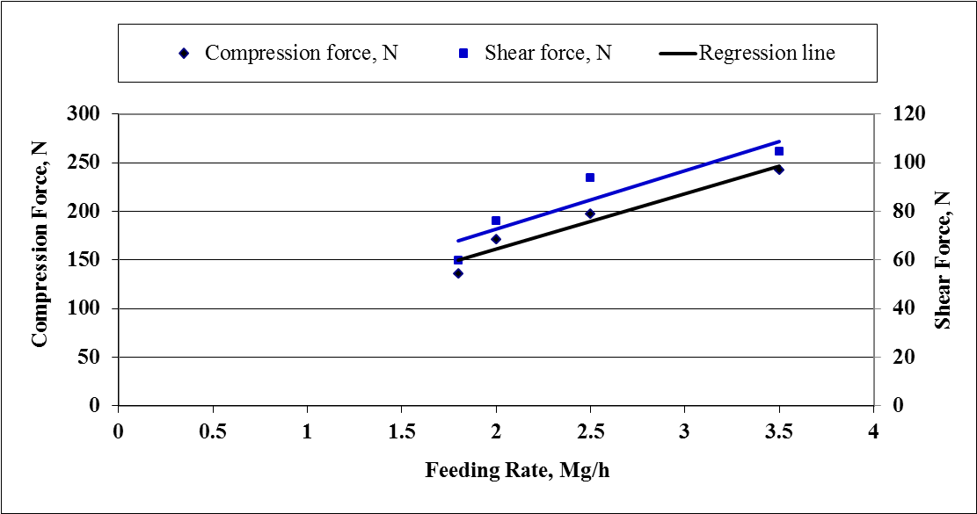
Figure 4.42 The effect of feeding rate of the pelletizer on the compression and shear forces of the large animal feed pellets.

Regression analysis was carried out to find a relationship between the feeding rate of the pelletizer and both compression and shear forces of the feed pellets. The most suitable forms obtained were listed in table 6.
Table 6 Relationship between the feeding rate on the compression and shear forces of the different feed pellets their constants and coefficient of determinations.
Type of feed | Variables |  | Constants |  | R²
 | Dependent | Independent | A | B
Rabbits feed pellets | SF | Fr | 26.54 | 20.29 | 0.93
 | CF | Fr | 104.10 | 238.78 | 0.94
 | CF | SF | 3.89 | 160.43 | 0.99
poultry feed pellets | SF | Fr | 12.49 | 18.11 | 0.95
 | CF | Fr | 22.44 | 85.61 | 0.99
 | CF | SF | 1.75 | 54.46 | 0.98
Large animal feed pellets | SF | Fr | 24.04 | 24.66 | 0.85
 | CF | Fr | 57.05 | 46.79 | 0.94
 | CF | SF | 2.23 | 0.25 | 0.96

Where CF is the compression force, N, SF the shear force, N, Fr the feeding rate, Mg/h, A slope and B intercept.
CONCLUSION
- For the rabbits feed pellets, the highest specific energy consumption (204.60 kJ/kg) was obtained at 0.40 Mg/h feeding rate which decreased to the lowest specific energy consumption (179.14 kJ/kg) which obtained at 0.70 Mg/h feeding rate.
- For the poultry feed pellets, the highest specific energy consumption (184.87 kJ/kg) was obtained at 0.60 Mg/h feeding rate which decreased to the lowest specific energy consumption (163.60 kJ/kg) which obtained at 0.90 Mg/h feeding rate.
- For the large animals feed pellets, the highest specific energy consumption (59.67 kJ/kg) was obtained at 1.80 Mg/h feeding rate which decreased to the lowest specific energy consumption (41.06 kJ/kg) which obtained at 3.50 Mg/h feeding rate.
- For rabbits feed pellets, the highest compression and shear forces 309.11 and 38.02 N, respectively, was obtained at 0.70 Mg/h feeding rate which decreased to the lowest compression and shear forces 277.16 and 30.12 N, respectively, which obtained at 0.40 Mg/h feeding rate.
- For poultry feed pellets, the highest compression and shear forces 106.08 and 29.60 N, respectively, was obtained at 0.90 Mg/h feeding rate which decreased to the lowest compression and shear forces 99.22 and 25.60 N, respectively, which obtained at 0.60 Mg/h feeding rate.
- For large animals feed pellets, the highest compression and shear forces 242.08 and 104.66 N, respectively, was obtained at 3.50 Mg/h feeding rate which decreased to the lowest compression and shear forces 135.63 and 59.92 N, respectively, which obtained at 1.80 Mg/h feeding rate.

REFERENCES
Beumer, H. 1980. Consommation et possibilite d’economie d’energie dans l’industrie de l’aalimentation animale: une orientation (en neerlandais) Inst. for grann meel en brood. TNO Wageningen. Rapport, 80-145.
Briggs, J. L., D. E. Maier, B. A. Watkins and K. C. Behnke. 1999. Effects of ingredients and processing parameters on pellet quality. Poultry Science, 78:1464–1471.
Cutlip, S. E., J. M. Hott, N. P. Buchanan, A. L. Rack, J. D. Latshaw and J. S. Moritz. 2008. The effect of steam- conditioning practices on pellet quality and growing broiler nutritional value. Journal of Applied Poultry Research, 17: 249- 261.
Israelsen, M., J. Busk and J. Jensen. 1981. Pelleting properties of dairy compounds with molasses, alkali-treated straw and other byproducts. Feedstuffs, 7:26–28.
Kulig R. and J. Laskowski. 2005. Wpływ zawartości tłuszczu na proces granulowania materiałów paszowych. Inżynieria Rolnicza, 7(67): 59-68.
Kulig, R. and J. Laskowski. 2008. Energy requirements for pelleting of chosen feed materials with relation to the material coarseness. TEKA Kom. Mot. Energ. Roln. – OL PAN, 8: 115–120.
Kulig, R. and J. Laskowski. 2009. Energy requirements for the pelleting of broiler premium grower diets with a different soybean oil content. TEKA Kom. Mot. Energ. Roln. – OL PAN, 9: 138–144.
Kurt, G. l979. Engineering formulas. 3rd. Ed. Mc Graw – Hill book Co.
Laskowski, J. and S. Skonecki. 1999. Energochłonność granulowania mieszanek paszowych. Mat. II Międzynarodowej Konferencji Naukowo-Technicznej Motrol ’99, Lublin, Nałęczow 8-9. 09. 99 r., cz. 2, 124-131.
Metwally, K. A. 2010. Study the effect of some operational Factors on hammer mill. A MSC thesis of Department of Agricultural Engineering, Faculty of Agriculture, Zagazig University. Egypt.
Opielak, M. 1997. Wybrane zagadnienia rozdrabniania materiałow w przemyśle rolnospoŜywczym. Rozprawy Naukowe AR Lublin, z. 200.
Peisker, m. 2006. Feed processing- Impacts on nutritive value and hygienic status in broiler feeds. Proceedings of the Australian Poultry Science Symposium, 18: 7- 16.
Romański, R. 1999. Badania rozdrabniaczy dwuwalcowych w aspekcie zuŜycia energii I zawartości frakcji pylistej w śrucie. InŜ. Roln., 5: 361–365.
Skoch, E. R., K. C. Behnke, C. W. Deyoe and S. F. Binder. 1981. The effect of steam-conditioning rate on the pelleting process. Animal Feed Science and Technology, 6:83–90.
Stevens, C. A. 1987. Starch gelatinization and the influence of particle size, steam pressure and die speed on the pelleting process. Ph.D. dissertation. Manhattan, KS: Kansas State University.
Tabil, Jr. L. G. 1996. Binding and pelleting characteristics of alfalfa. Ph.D. dissertation. Saskatoon, Saskatchewan, CA: Department of Agricultural and Bioresource Engineering, University of Saskatchewan.
Tabil, Jr. L. G., S. Sokhansanj and R. T. Tyler. 1997. Performance of different binders during alfalfa pelleting. Canadian Agricultural Engineering, 39:17–23.
Wood, J. F. 1987. The functional properties of feed raw materials and the effect on the production and quality of feed pellets. Animal Feed Science and Technology, 18:1– 17.

تأثير معدل التغذية على استهلاك الطاقة والخصائص الميكانيكية للأنواع المختلفة من العلف المكبوس
مختار دبور، عادل بهنساوى، سمير احمد على²، زكريا الحداد
قسم الهندسة الزراعية- كلية الزراعة- جامعة بنها

اجريت هذه الدراسة لتحسين بعض عوامل الكبس وتأثيرها على جودة العلف المكبوس. تم تقييم المكبس عند اختلاف معدل التغذية على الانواع المختلفة من الاعلاف لدراسة استهلاك الطاقة النوعى، وكذلك جودة المكبوس تحت ظروف التشغيل المختلفة. وقد اظهرت نتائج تقييم المكبس أن الاستهلاك النوعى للطاقه فى عملية الكبس تراوحت قيمته بين 179,14- 204,60 كجول/كجم لعلف الأرانب، 163,60- 184,87 كجول/كجم لعلف الدواجن و41,06- 59,67 كجول/كجم لعلف المواشى. بينما تراوحت قيم مقاومتى الضغط والقص للمصبعات بين 277,16- 309،11 و 30,12- 38,02 نيوتن على التوالى لعلف الأرانب المكبوس، 99,22- 106,08 و 25,60- 29,60 نيوتن على التوالى لعلف الدواجن المكبوس و 135,63- 242,08 و 59,92- 104,66 نيوتن على التوالى بالنسبة لعلف المواشى المكبوس عند اختلاف معدل التغذية.
الكلمات الدالة: الكبس، استهلاك الطاقة النوعى، قوة الضغط، قوة القص، العلف المكبوس.

معيد بقسم الهندسة الزراعية – كلية الزراعة - جامعـة بنهــا.
استاذ الهندســة الزراعيـــة - كلية الزراعــة - جامعـــــة بنهـا.
استاذ الهندسة الزراعية المتفرغ – كلية الزراعة - جامعة بنها.

